Rafting Site – Planning Document
Selected Logo
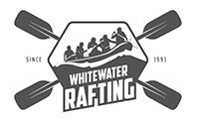
Whitewater Rafting Logo
Selected Colors
- primary-color: #13315C body text
- secondary-color: #55828B header
- accent1-color: #73E2A7 link
- accent2-color: #F8F0FB background
Selected Fonts
- Heading-font: Rock Salt
- Text-font: Roboto, regular
URL Link (Color Palette)
https://coolors.co/73e2a7-55828b-f8f0fb-13315c

